**14. Sentence Agreement Check Using CFG**

**Aim:**  
To check for grammatical agreement in a sentence based on CFG rules.

**Algorithm:**

1. Define a CFG that enforces agreement rules.
2. Parse the input sentence.
3. Validate if the sentence adheres to the grammar.

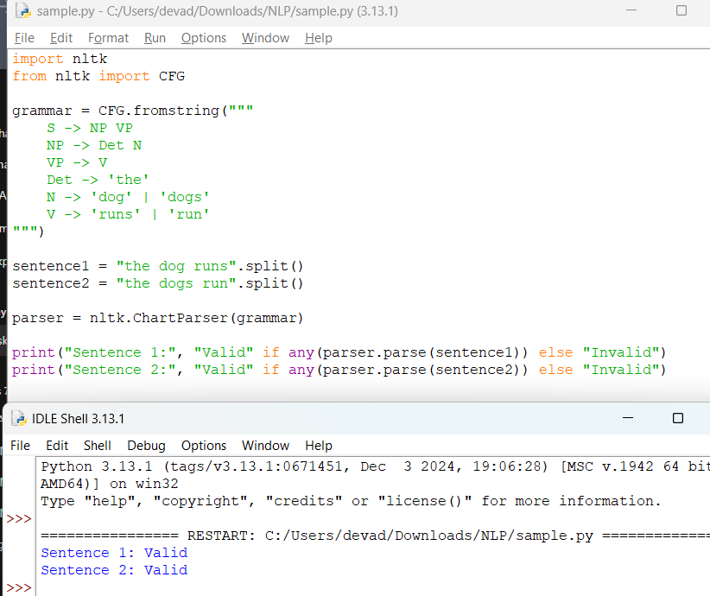

**Result:**  
The program checks sentence agreement successfully.